

Past Performance
Arial 20 bold

This document provides you with information on past performance. Nordea Sans Small 8

Past performance is not a reliable indicator of future performance. Markets could develop very differently in the future. Nordea Sans Small 8 bold [regulatory text] There is a text below with a comment where it says the following.t

Nordea Fixed Income Credit Opportunities Fund I growth EUR Nordea Sans Small 12 bold
/ distribution FI4000148085 / FI400014807 (in the same way as in the KID) Nordea Sans Small 8

The fund is managed by Nordea Funds Ltd which is part of the Nordea Group. Nordea Sans Small 8 bold The Finnish Financial Supervisory Authority is responsible for supervising Nordea Funds Ltd in relation to this document. Nordea Funds Ltd is authorised in Finland and regulated by the Finnish Financial Supervisory Authority. This fund is authorised in Finland. Nordea Sans Small 8 [to be sourced from WB_Generalinformation_5 from the KID)

Date of Production dd/mm/yyyy Nordea Sans Small 8-

This chart shows the fund’s performance as the percentage loss or gain per year over the last X years against its benchmark. It can help you to assess how the fund has been managed in the past and compare it to its benchmark. Nordea Sans Small 8 bold [regulatory text, the wording concerning benchmark should only be added if the fund has a benchmark]. There are only two funds out of 102 funds registered in Finland without a benchmark among the funds with a FI ISIN code at the moment).

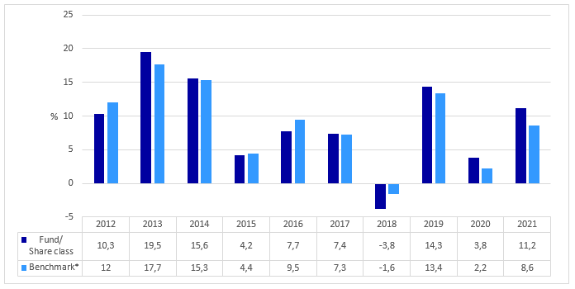

Performance is shown after deduction of ongoing charges. Any entry and exit charges are excluded from the calculation. [regulatory text] Nordea Sans Small 8
The fund was launched on dd/mm/yyyy. [to be sourced from the FMF: “Launch Date Fund”] Nordea Sans Small 8
The share class was launched on dd/mm/yyyy. [to be sourced from the FMF: “Launch Date Share Class”] Nordea Sans Small 8
Calculation currency XXX. Nordea Sans Small 8

*Benchmark: MSCI World excl Sweden Net Return 3.30%, MSCI World High Dividend Net Return Hedged to SEK 22.20%, OMX Stockholm Benchmark ESG Responsible Capped Gross Index 4.50%, OMRXMT13 10.50%, OMRXMT35 38.50%, OMRXMUNI 21.00%, including dividend (1st of January 2023). [to be sourced from the FMF: wb_Benchmark (global domain)] Nordea Sans Small 8

Information about previous benchmarks is available in the annual and semi-annual reports. Nordea Sans Small 8 Is already shown in the current KPP:

For share classes which do not yet have performance data for one complete calendar year, a statement shall be included explaining that there is insufficient data:
“This fund/share class does not have a full calendar year performance.“ Nordea Sans Small 8

Also free text field is needed, in case there is need to have warning about the lack of representativeness of the past performance
For the Finnish funds with an FI “ISIN code” these sentences
”The performance figures presented in the past performance are based on the performance of the growth unit. Due to computational reasons, small differences can occur between the growth and distribution units.” Nordea Sans Small 8
Page 1 of 1

